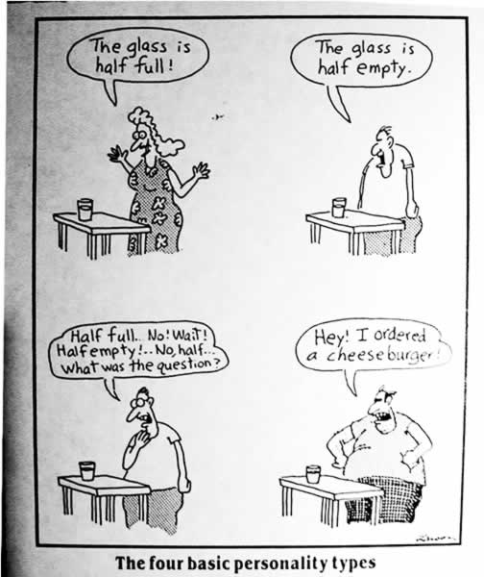
Name: ______________________ Personality Profile Sheet

Directions: Explain the differences in the following comparisons:

@ Introvert vs. Extrovert

§ Sensing vs. Intuition

∞ Thinking vs. Feeling

® Judgement vs. Perception

General Personality Profile Information
1. What are the four major temperaments?
#1: ______________________________________ #2: _____________________________________
#3: ______________________________________ #4: _____________________________________

2. Summarize qualities (1 detail) for each major temperament.
#1: ______________________________________ #2: _____________________________________
#3: ______________________________________ #4: _____________________________________

3. What are the 16 minor temperaments?

Personal Personality Profile Information

1. I am a(n) _________________________ (one of the four major temperaments)

2. I am a(n) _________________________ (one of the sixteen minor temperaments)

3. The letters of my full temperament (major and minor) are ___________.

4. The summarized characteristics of my minor temperament are: (four details)
#1: ____________________________________________________________________________________________________________
#2: ____________________________________________________________________________________________________________
#3: ____________________________________________________________________________________________________________
#4: ____________________________________________________________________________________________________________

5. Do you agree with this perception of your personality? Specifically why or why not?

Your Temperament in Action

8. List four career choices most suited to your temperament.
#1: ______________________________________ #2: _____________________________________
#3: ______________________________________ #4: _____________________________________

9. Based on your temperament, what is your learning style? (4 details)
#1: ____________________________________________________________________________________________________________
#2: ____________________________________________________________________________________________________________
#3: ____________________________________________________________________________________________________________
#4: ____________________________________________________________________________________________________________

10. How is your learning improved? (Identify 4 ways)
#1: ____________________________________________________________________________________________________________
#2: ____________________________________________________________________________________________________________
#3: ____________________________________________________________________________________________________________
#4: ____________________________________________________________________________________________________________

11. How is your learning hindered? (List 4 ways)
#1: ____________________________________________________________________________________________________________
#2: ____________________________________________________________________________________________________________
#3: ____________________________________________________________________________________________________________
#4: ____________________________________________________________________________________________________________

12. According to your temperament, how do you best communicate? (Identify 2 details)
#1: ____________________________________________________________________________________________________________
#2: ____________________________________________________________________________________________________________

13. List two strategies for successful communication that you see yourself putting into use.
#1: ____________________________________________________________________________________________________________
#2: ____________________________________________________________________________________________________________

14. What aids successful communication? (2 items)
#1: ____________________________________________________________________________________________________________
#2: ____________________________________________________________________________________________________________

15. What hinders successful communication? (2 items)
#1: ____________________________________________________________________________________________________________
#2: ____________________________________________________________________________________________________________

16. Mention 2 famous people with your temperament. What quality do you admire in them?
#1: ____________________________________________________________________________________________________________
#2: ____________________________________________________________________________________________________________

17. How will knowing this information about yourself help you in your relationships? (at school, at home,
etc.)
At home:

At school:

