General MLA Format & Quotation Information
Modern Language Association (MLA) style is most commonly used to write papers and cite sources within the liberal arts and humanities. Writers who properly use MLA also build their credibility by demonstrating accountability to their source material. Most importantly, the use of MLA style can protect writers from accusations of plagiarism, which is the purposeful or accidental uncredited use of source material by other writers.

General Guidelines for the final exam
- Use an MLA Heading in upper left-hand corner
- Center your title and use standard capitalization; Don’t underline or put title in quotation marks
- Double-space the entire text of your paper
- Indent the first line of paragraphs
- In the upper right-hand corner, write your last name and the page number
- Underline the title of the play
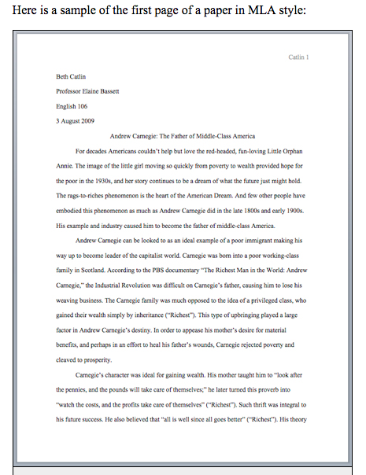

Short quotations
To indicate short quotations (fewer than four typed lines of prose) in your text, enclose the quotation within double quotation marks. Provide the author and specific page citation. Punctuation marks such as periods, commas, and semicolons should appear after the parenthetical citation. Question marks and exclamation points should appear within the quotation marks if they are a part of the quoted passage but after the parenthetical citation if they are a part of your text.
For example, when quoting short passages of prose, use the following examples:
According to Foulkes's study, dreams may express "profound aspects of personality" (184).
OR
Is it possible that dreams may express "profound aspects of personality" (Foulkes 184)?

Adding or omitting words in quotations
If you add a word or words in a quotation, you should put brackets around the words to indicate that they are not part of the original text.
Jan Harold Brunvand, in an essay on urban legends, states, "some individuals [who retell urban legends] make a point of learning every rumor or tale" (78).
If you omit a word or words from a quotation, you should indicate the deleted word or words by using ellipsis marks, which are three periods ( . . . ) preceded and followed by a space. For example:
In an essay on urban legends, Jan Harold Brunvand notes that "some individuals make a point of learning every recent rumor or tale . . . and in a short time a lively exchange of details occurs" (78).
Please note that brackets are not needed around ellipses unless adding brackets would clarify your use of ellipses.

