Name: ___________________________________ MS Creative Writing
Date: ____________________________________ The Paragraph Story

THE PARAGRAPH STORY
The Paragraph Story Directions:
- You are going to write a paragraph that tells a story.
- Your paragraph will be a response to the questions below.
- Any sentence you write is OK, but you MUST follow the sequence of questions.
- You can ask for help while you are writing.

The Paragraph Story Questions:
- ​How long have you been on the planet?
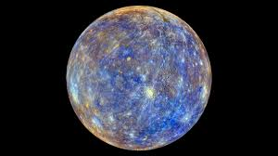

- Why did you go there?
- Describe the two people who are with you.
- Why is your spaceship damaged?

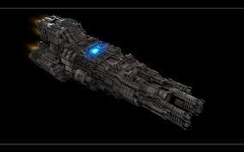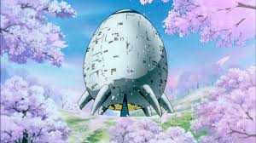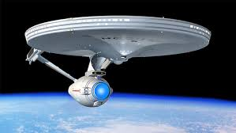

- When you decided to leave your ship, how far did you walk?
- What were you looking for?
- When did you realize that someone was following you?

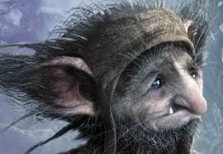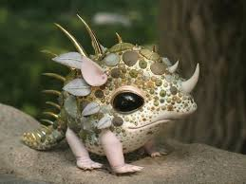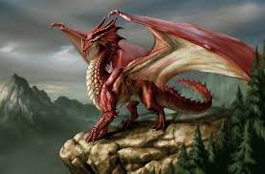

- Describe the creature.
- While you were running away, you tripped and fell. What happened?
- What was the big surprise at the end of your story?

The Paragraph Story Checklist:
- ALL questions are answered IN ORDER in my paragraph story.
- I have included images for the following elements:
  - The planet I am on
  - The two “people” I am with (do not have to be human)
  - My spaceship
  - Item, person, etc. that I’m are looking for
  - The creature following me
  - The big surprise at the end of my story

