Name: _______________________________ Lord of the Flies
Date: ________________________________ The Simpsons: “Das Bus” (Season 9, Ep. 14)

The Simpsons’ Cast
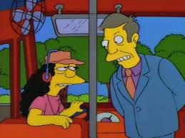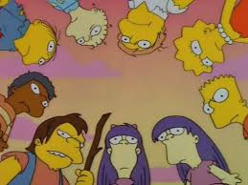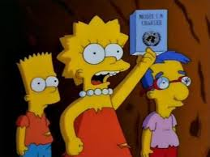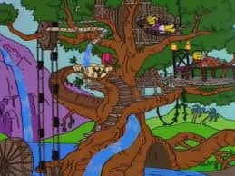
(L to R: Otto and Model UN Club* (L to R: Bart, Lisa and Swiss Family Robinson
Principal Skinner) Milhouse)

*Model UN Club (Top Center to R): Martin, Lisa, Bart, Sherri and Terri, Nelson, Lewis, Ralph and Wendell

Part One: Remembering (Use language accurately)
Directions: List ten elements from the text version that are present in The Simpsons’ version.

1. ___________________________________________________________________________________
2. ___________________________________________________________________________________
3. ___________________________________________________________________________________
4. ___________________________________________________________________________________
5. ___________________________________________________________________________________
6. ___________________________________________________________________________________
7. ___________________________________________________________________________________
8. ___________________________________________________________________________________
9. ___________________________________________________________________________________
10. __________________________________________________________________________________

Part Two: Explaining (Organizing arguments in a logical manner)
Directions: Which characters from Lord of the Flies (LOTF) are represented by The Simpsons’ cast? Use knowledge about the characters from both sources to explain why the match is probable.

1. LOTF _______________ = _______________ from The Simpsons’ cast
Rationale: ____________________________________________________________________________

2. LOTF _______________ = _______________ from The Simpsons’ cast
Rationale: ____________________________________________________________________________

3. LOTF _______________ = _______________ from The Simpsons’ cast
Rationale: ____________________________________________________________________________

4. LOTF _______________ = _______________ from The Simpsons’ cast
Rationale: ____________________________________________________________________________

5. LOTF _______________ = _______________ from The Simpsons’ cast
Rationale: ____________________________________________________________________________
Part Three: Commenting (Analysis of author’s choices on an audience)
Directions: First, identify ten ways the text is made humorous in the episode. Then, comment on how a text known for its darker themes is made funny by The Simpsons’ treatment.

Humorous moment | How was it made funny?
1.
2.
3.
4.
5.
6.
7.
8.
9.
10.

Key terms from www.merriam-webster.com:
- Satire definition (n.): Humor that shows the weaknesses or bad qualities of a person, government, society, etc.
- Parody definition (n.): A piece of writing, music, etc. that imitates the style of someone or something else in an amusing way

Is The Simpsons’ episode an example of a satire or a parody? Why?

Part Four: Cultural References/Literary Allusions
Directions: Identify the sources of the following cultural references and literary allusions. What were the authors trying to do by including these in the episode?

1. Story of Noah’s Ark: __________________________________________________________________
2. Children trapped on an island: __________________________________________________________
3. Principal Skinner’s shoe banging: ________________________________________________________
4. Milhouse won’t send the vine back to Bart and Lisa: ________________________________________
5. Ralph’s painted face: _________________________________________________________________

Inclusion hypothesis?

Part Five: ATL Environments
Directions: How does literature affect our understanding of different environments? Jot down a thesis statement that would capture your main ideas.

Note: One of Golding’s main ideas is that society keeps humans from becoming savage.
_______________________________________________________________________________________________________________________________________________________________________________________________________________________________________________________________

