Name: ________________________________ Th1rteen R3asons Why
Date: _________________________________ Public Service Announcement (PSA)

Directions: Individually, create an original public service announcement (PSA) advertisement addressing a relevant teen issue. Once your proposal has been approved, you may begin working on the final product.

DUE: Wednesday, June 8th (Day 4) @ end of class

A public service announcement (PSA) is a short message designed to inform and educate with the objective of raising awareness and changing public attitudes and behavior towards a social issue.

- Complete a PSA Proposal Form
  - Focus your brainstorm
  - Create an outline/overview for your PSA—slogan/phrase & visuals, etc.
  - Mock PSA created and approved (words & image(s) on page)—placement, color, etc.
- Identify your topic
  - Pinpoint a teen issue to focus on
  - Develop the key message(s) you want audience (teens) to absorb
- Research the topic
  - In your topic, what messages have been used? (Find at least 2 different examples of how your topic can be approached and print examples for proposal)
  - You will create an original viewpoint to highlight
  - Make sure that any data or claims you plan to include in the PSA are backed by research and evidence and are up to date
  - Create a Works Cited document for source material as needed.
- Language of the PSA
  - Create a short slogan/phrase to make your message crystal clear
  - MUST be an original slogan/phrase
  - Use simple, concise and vivid language; conversational
  - Use language that will attract your audience
  - Goal: Inform? Inform & take action? How will you know your PSA is effective?
    - Goal to inform: Ex: “If you are between the ages of 15-25...”
    - Goal to take action: Ex: “Go to this website...donate to...etc.”
- Create a visual plan
  - What image(s) will clearly convey your idea? How effectively arranged on page?
  - MUST be an original image
- Complete the PSA Checklist
  - Double-check required elements before submitting
  - Proposal materials submitted too

PSA Checklist:

___You have brainstormed ideas for your PSA (The PSA Proposal).
___You have decided upon and clarified the purpose of your PSA.
___You have targeted your audience.
___You have found and printed at least 2 examples of other ads regarding your topic.
___You have selected a unique angle to highlight your topic.
___You have checked your facts.
___You have decided to inform OR inform & encourage a specific action.
___You have identified a "hook" for your PSA.
___You have an effective slogan/phrase.
___You have created an effective & original image(s).
___You have completed a mock layout of your words and images—placement, color, etc.
___You have an approved PSA Proposal Form & completed the PSA Checklist.

Example PSAs: Water Conservation

Directions: Identify if the following PSA examples inform OR inform & ask you to take action.

Example #1: ___________________________________________________________________

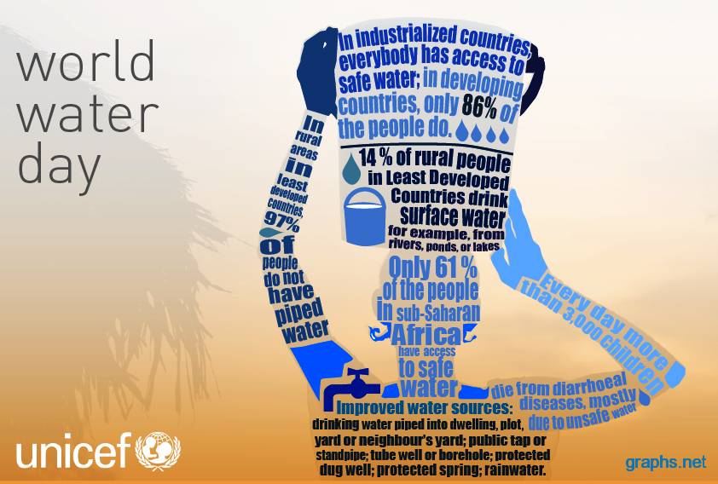
Example #2: ___________________________________________________________________

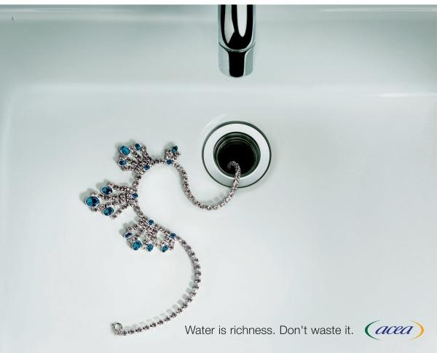

Example #3: ___________________________________________________________________
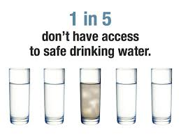
Example # 4: ___________________________________________________________________

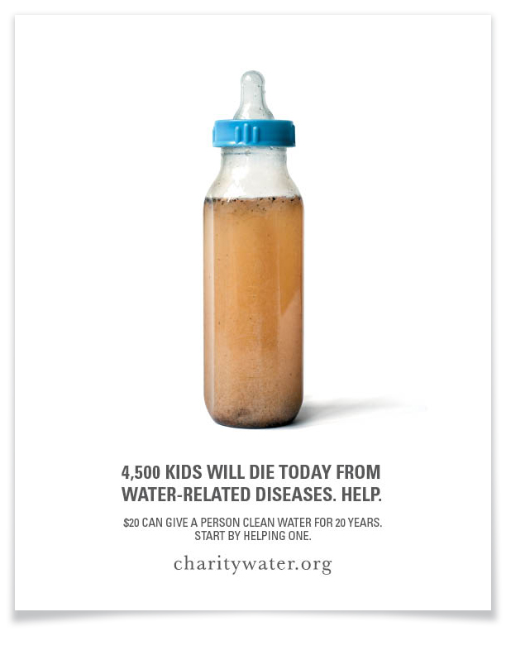
Question: In your opinion, which example is most effective? Why?

